Document Writing
Project by:

Syed Ali Zain

Database Normalization

Database Name: appdb
This section outlines the normalization process applied to the database used in the DailyHeadlines application. The goal of normalization is to minimize data redundancy and improve data integrity.

1. First Normal Form (1NF)
Definition:
A table is in First Normal Form (1NF) if:
- It contains only atomic (indivisible) values.
- There are no repeating groups or arrays.
- Each record is uniquely identifiable by a primary key.
Application:
Both Userss and News tables meet the requirements of 1NF:
- All attributes store atomic values (e.g., name, email, title, etc.).
- Each table has a defined primary key (Id).
Conclusion:
- Userss table is in 1NF.
- News table is in 1NF.

2. Second Normal Form (2NF)
Definition:
A table is in Second Normal Form (2NF) if:
- It is already in 1NF.
- Every non-prime attribute is fully functionally dependent on the whole primary key.
Application:
Since both Userss and News tables use a single-column primary key (Id), partial dependencies do not exist. All non-key attributes depend entirely on the primary key.
Conclusion:
- Userss table is in 2NF.
- News table is in 2NF.

3. Third Normal Form (3NF)
Definition:
A table is in Third Normal Form (3NF) if:
- It is in 2NF.
- There are no transitive dependencies (i.e., non-key attributes do not depend on other non-key attributes).
Application:

Userss Table:
- All fields such as Name, Email, Password, Role, and CreatedAt depend directly on the primary key Id.
- No transitive dependencies exist.
Conclusion:
- Userss table is in 3NF.

News Table (Initial Design):
- The Author column stores the name of the person who posted the news.
- However, this field is not linked to the Userss table via a foreign key, which introduces a potential transitive dependency (e.g., News → AuthorName → User).
To resolve this, the News table should reference the Userss table using a foreign key (UserId). This ensures referential integrity and proper normalization.

Revised News Table Structure:
Column | Data Type | Description
Id | INT (PK) | News ID
Title | NVARCHAR(255) | News headline
Description | NVARCHAR(MAX) | Detailed content
ImageUrl | NVARCHAR(500) | Image link for the news (optional)
DatePosted | DATETIME | Timestamp of when the news was added
UserId | INT (FK) | References Userss(Id)

Normalization Summary
Table Name | 1NF | 2NF | 3NF | Remarks
Userss | Yes | Yes | Yes | Fully normalized
News | Yes | Yes | No | Becomes 3NF after adding UserId as a foreign key (FK)

Relational Schema:

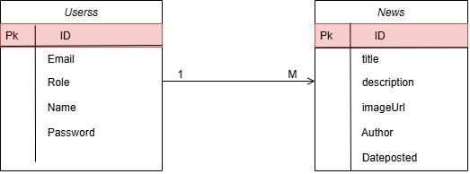

ERD Diagram:

